Task : Workflow of creating a real-time chat application backend using Nosql
Requirements:
1. Enable Firestore (Native mode).
-- Enabled the firestore to the native mode during the creation firestoreDB
2. Create a collection chats.
-- Created the chats collection to store the
messages between the users
3. Each document should store:
• sender
• receiver
• message
• timestamp
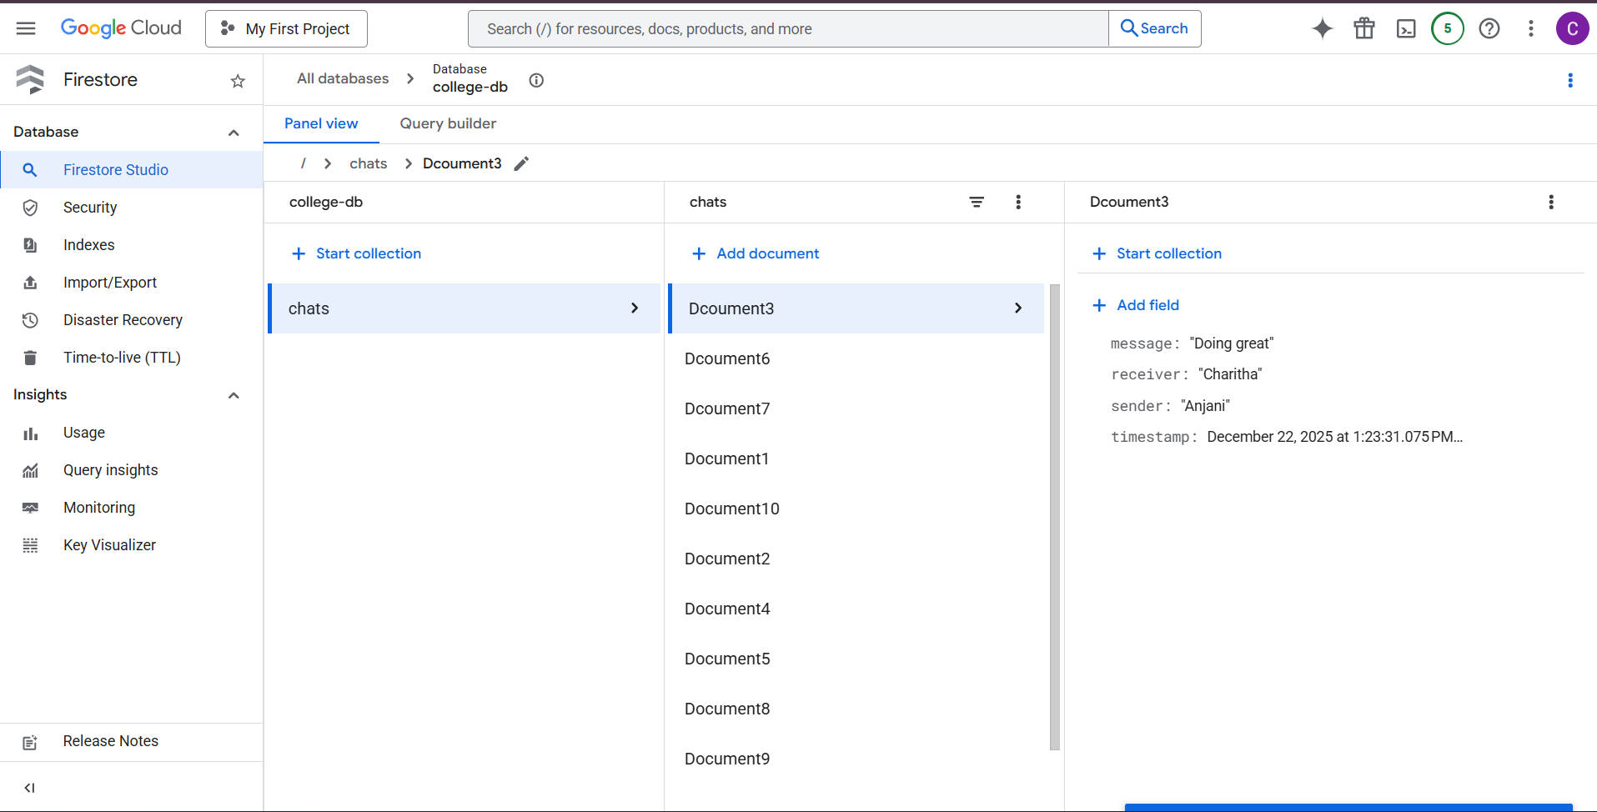

4. Perform the following:
• Insert at least 10 chat messages

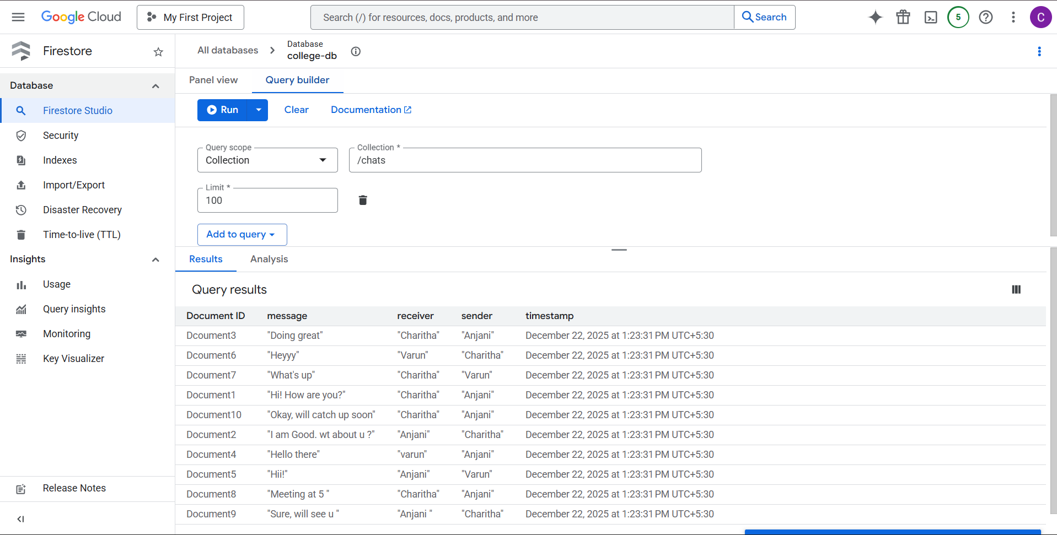

• Query all messages between two users

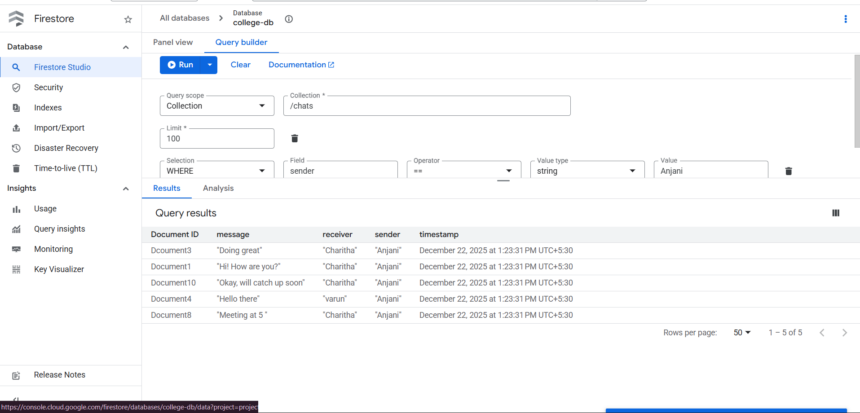

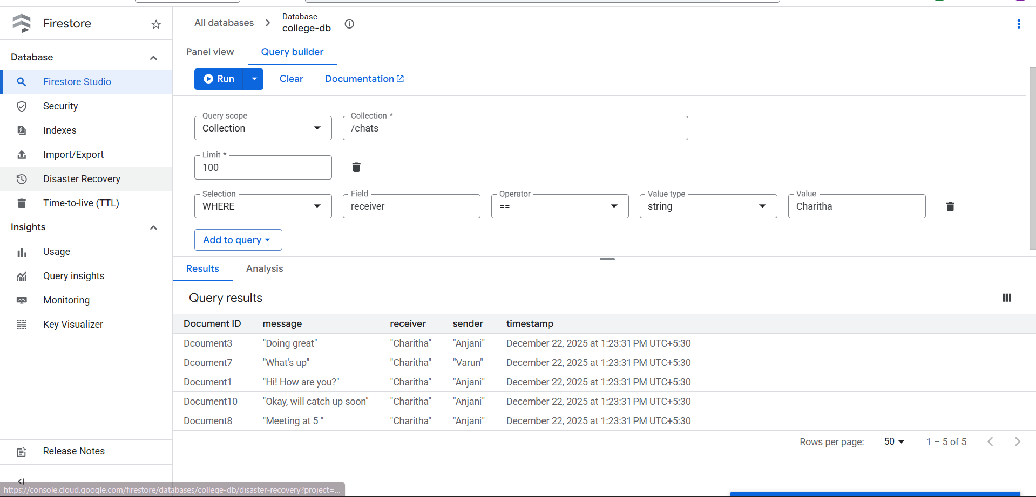
. Sort messages by timestamp
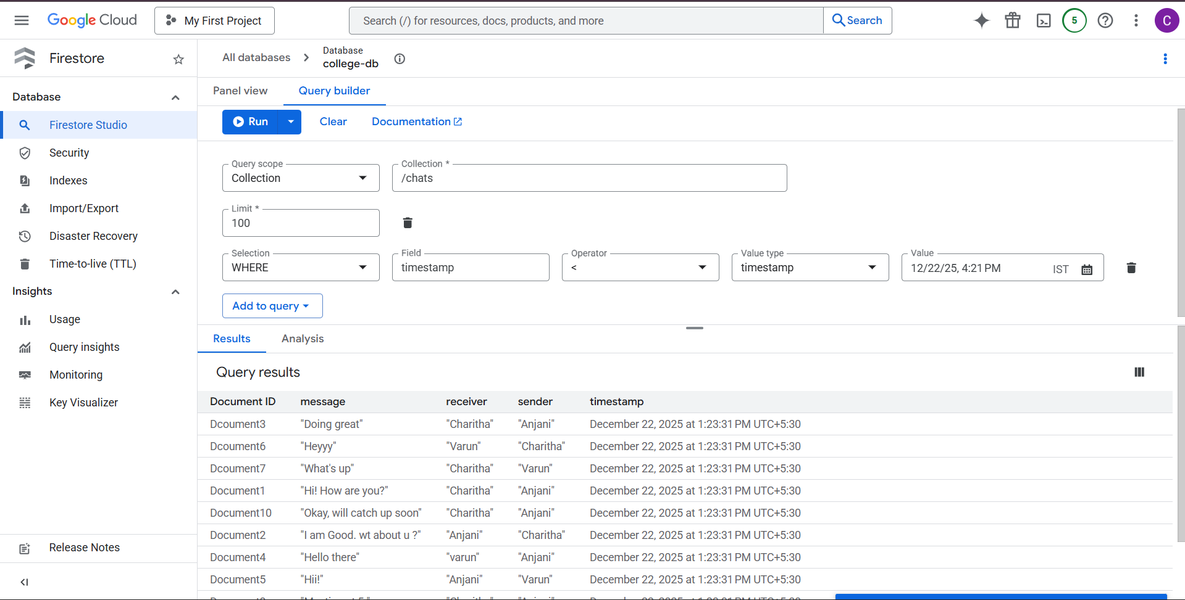
- Create a Firestore security rule:
• Only authenticated users can read/write

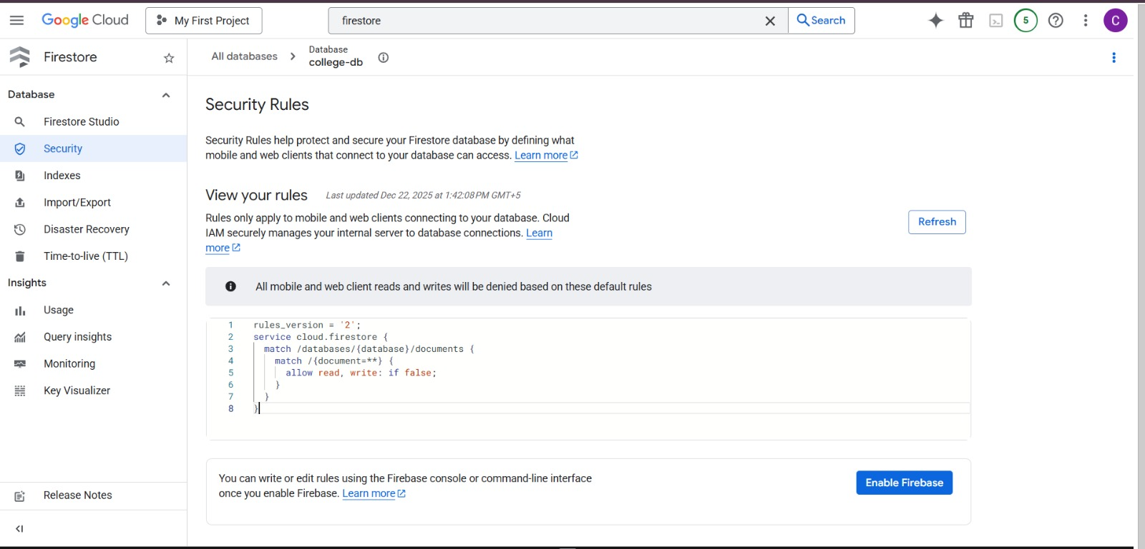
. Users can read only their own chats

Expected Skills Tested
• Firestore data modeling
• NoSQL querying
• Security rules

